School of Engineering, Applied Sciences and Technology ENG 210 – Computer Architecture | Spring 2024-25

Final Lab Assignment/Project
Course Code: ENG 210 | Course Name: Computer Architecture
Deadline: 20 April 2025 | Date: 21 March 2025 – 20 April 2025
Location: To be uploaded on Moodle | Instructor(s): Dr. Kuljeet Kaur

Course Learning Outcomes (CLO) | Final Assignment/Project
CLO1: Explain the basic architecture of a computer and its main components.
CLO2: Describe the Internal structure of the computer memory and demonstrate the interaction between CPU and memory.
CLO3: Explore design enhancement, and implementation for both CPU and memory.
CLO4: Identify the main factors involved in I/O process and demonstrate the various techniques used for interface between I/O peripheral devices, CPU and memory.
CLO5: Apply a computer instruction set. | X

CLO Mappings
CLO 5/ 20 Marks | Total  20 Marks

Note: Grade will be re-scaled to match the exact weight of each part
Student ID | Student Name | Report  (10 Points) | Q&A  (10 Points) | Total  (20 Points)
2022002536 | Maryam Alyaseen
20230003378 | Fasmin Nizar
20220002085 | Hassan Mujtaba
20230003282 | Devanarayan KS

Project Description and Requirements

You are asked to implement the below tasks and all the required documents (as asked) including the attachments of the implementation source code and program output screenshots.

Submission Instructions

- This is a group-based assignment (4 members per group).
- The assignment consists of two parts: Implementation & Reporting part and the Q&A session.
- Implementation & Reporting Part (One common grade for the entire group):
  - Your implementation should work.
  - Show the wiring diagram on Tinkercad.
  - Source code provided.
  - Test case results (as clarified).
  - You should provide screenshots of all the outputs
  - You should provide screenshots of your physical parts.
  - References are provided and cited properly.
- Q&A Part (Individual grade):
  - Each student will be asked individually.
  - The questions cover the theory and practice of the project.
- Your report must have the names of all the team members.
- Your report must be well organized and structured.
- You must upload your report (including the source code) for your project by the deadline.
- Upload only one submission per group. In case of multiple submission from the same group, the group will automatically lose 50% of the assignment grade.
- The report will be checked towards similarity using Turnitin tool to report similarity and AI generated text. Any violation of the academic integrity policy, including plagiarism is a serious offence that will be sanctioned as per the Academic Integrity Policy published in the Student Handbook.
- The report must be in text not images, in case of the submission of the text as images, the group will receive a zero mark for this project.
- For the Q&A session, each team must have a printed copy of the report with the team member names on the cover page.

Rubric

Criterion | Needs Improvement Good  [0-3] [4-7] |  | Excellent [8-10]
Q&A | The student provided poor answers and insufficient evidence of contribution to the assignment. | The student answered some of the questions correctly and  showed some  contribution to the assignment. | The student answered all questions correctly and showed genuine contribution to the assignment.
Criterion | Needs  Improvement  [0-1] | Good  [2-3] | Excellent [4-5]
Coding &  Report | The code does not work properly, many requirements are missing, and the report does not provide enough proofs  (screenshots) of testing scenarios. | The code works partially and  implements some of the requirements; the report shows some testing scenarios. | The code works fully and as expected per the requirements and the report shows all testing scenarios.

Project Guidelines Innovative Automation Solutions for Clean Energy and Sustainability
- Introduction
As the global demand for energy continues to rise, the need for sustainable and efficient energy solutions has never been greater. This project inspires students to explore automation and smart energy management technologies to create innovative solutions that enhance energy efficiency, promote renewable energy usage, and contribute to environmental sustainability. Through hands-on experimentation and problem-solving, students will develop systems that monitor and optimize energy consumption in homes, businesses, and/or public infrastructure.
- Objective
The primary goal of this project is to encourage students to design and implement automation solutions that align with SDG 7: Affordable and Clean Energy. Using platforms such as Arduino, Raspberry Pi, or IoT-based systems, students will build prototypes that intelligently manage energy resources, integrate renewable energy sources, and enhance energy efficiency in various settings.
- Project Scope
Students are encouraged to propose and develop automation projects under the following themes:
  - Smart Solar Energy Management Systems: Develop systems that monitor and optimize the use of solar power in residential and commercial buildings. This could include automated solar panel tracking systems, solar battery storage management, and intelligent energy distribution networks.
  - Energy-Efficient Smart Homes: Design automation solutions that reduce energy waste in homes by implementing automated lighting, smart HVAC systems, and energy monitoring dashboards. These systems will analyze real-time energy usage and suggest optimizations.
  - Smart Street Lighting Systems: Create intelligent solar-powered streetlights that adjust brightness based on ambient light and motion detection. This ensures maximum energy savings while maintaining urban safety.
  - Renewable Energy Microgrids: Implement smart microgrid management systems that integrate solar, wind, and battery storage for decentralized power generation. These systems will optimize energy distribution and reduce reliance on fossil fuels.
  - Automated Energy Auditing Systems: Develop IoT-enabled devices that monitor energy usage in real-time, detect inefficiencies, and suggest improvements for households, industries, and public institutions.
  - Green Energy Solutions for Smart Cities: Design automated energy management solutions for urban infrastructure, such as smart traffic lights, public transport charging stations, and solar-powered urban amenities to promote energy sustainability.

INDEX:

Sr no: | Topic | Pg No:
1 | Abstract | 7
2 | Project objectives | 7
3 | Relevance and Importance of Project | 7-8
4 | Project description and Requirements | 8
5 | Hardware | 8-9
6 | Software | 9-10
7 | System Design | 10-11
8 | Block diagram | 12
9 | Circuit diagram | 13
10 | Flowchart | 14
11 | Implementation details with Source Code | 15-17
12 | Test Cases and Results | 18-20
13 | Future Work | 21
14 | Conclusion | 21
15 | References | 21

Report:
Title: Smart Street Lighting Systems
Abstract:
The Smart Street lighting system is an energy efficient solution which was designed to optimize energy usage by controlling the streetlight based on the environmental conditions and motion detection. The project makes use of a photoresistor which controls the intensity of light which signifies whether it is day or nighttime, an ultrasonic sensor which is used for motion detection, a solar cell and battery for sustainably storing and using energy to power the circuit, emphasizing sustainability and intelligent power management for modern urban infrastructure. Finally, we use the LCD to display the necessary outputs on the screen. This project is done with the incentive to emphasize the Sustainable Development Goals specifically SDG no:7 Affordable and Clean Energy.
Project Objectives:
1. Automate Street Lighting: Develop a system that turns the streetlights dynamically on or off based on ambient light and motion detection.
2. Emphasizing energy efficiency: Minimize the power consumption by ensuring lights operate only when it is nighttime and only when there is an object approaching nearby or when it is in motion.
3. Improve Public safety: Ensure adequate illumination when motion is detected at night to improve visibility and safety.
4. Real time Monitoring: Display the necessary data during daytime and nighttime on the lcd screen to give users better insights on how our system works.
5. Low-cost implementation: The system is designed using affordable components to allow for scalable deployment even in less developed areas.
Relevance and Importance of the Project:
The Smart street lighting system tackles critical urban challenges related to efficient energy consumption, road safety and sustainability. Conventional lighting systems often lead to unnecessary energy consumption due to their continuous use, even though it is not consistently required. This project introduces a smarter, sensor-based lighting solution that adapts to the environmental changes as and when necessary. The combination of the photoresistor, ultrasonic sensor accompanied with the solar cell reduces the reliance on the power grid, gives importance to environment sustainability and also provides a better alternative to the outdated lighting methods. This project also contributes to the development of smart cities where efficient resource management and automation are the topmost priority. It also promotes environmentally conscious technological development.
Project description:
The smart street lighting system is an evolution to the traditional street lighting system which was designed to promote efficient use of energy and to advocate a sustainable urban infrastructure. This street light system makes use of a solar cell, a photoresistor, battery, ultrasonic sensor, lcd, 3 LEDs with resistors and an Arduino board to dynamically control streetlights based on environmental conditions and presence of motion. During the day when there is abundant sunlight the system is inactive as it is conserving energy. However during the night due to the presence of low ambient light the system gets activated, that is when the presence of an object is detected by the ultrasonic sensor the relevant LED’s illuminate ensuring safety and also preventing energy wastage. The system gets powered by a solar cell which charges the battery making it feasible for off grid or low infrastructure areas.
Project requirements:
- Arduino
- LED
- Ultrasonic sensor
- 4. Photoresistor
- Solar cell
- Battery
- LCD
Hardware:
Arduino: It is the central microcontroller which is responsible for processing inputs from the ultrasonic sensor and photoresistor and controls the outputs on the LCD and LED as required. It makes use of the analog signal from the photoresistor and ultrasonic sensor to detect light and movement respectively.
LED: gives or does not give light based on the conditions provided. Anode connects to the pins D11,D12,D13. Cathode connects to the GND through the resistor.
Ultrasonic sensor: Measures distance for motion detection.
Trig pin:sends a pulse that allows the ultrasonic sensor to emit a sound wave.
Echo pin: listens for the sound wave that is reflected back and notes the time it takes for the wave to come back
PINS | CONNECTIONS
VCC | 5V
GND | GND
TRIG | D3
ECHO | D2

Photoresistor (LDR): Measures the intensity of light to detect whether it is daytime or nighttime.
Bright light (701-1023) approx. values
Low light (0-700) approx. values
Solar cell: facilitates charging the battery during the day.
Battery(9V): ensures that the street lighting system remains active during the night . Helps charge the entire system.
LCD: Displays information about the light level, distance and other conditions.
SDA connected to the A4 pin and the SCL which is connected to A5 connects the LCD to the Arduino.
Software:
The smart streetlight uses ARDUINO UNO microcontroller to control the system. It incorporates an LCD display along with a light and ultrasonic sensor which helps the system adapts to the light condition based on motion and intensity of the ambient light

Software functionality
1. LCD Display
- The Adafruit LiquidCrystal library is used to interact with the LCD.
- Displays system startup message(“Smart Streetlight”).
- Shows sensor values dynamically.
2. Sensor Integration
- Light Sensor (A0): Measures the brightness of the ambient light .
- Ultrasonic Sensor (Echo on pin 2, Trigger on pin 3): measures the distance to object .
3. Logic of light control
- Daytime Detection (sensorval > 700): Turns off all streetlights.
- Motion Detection (based on distance):
- 100 cm:All streetlights turn on.
- 100–200 cm: Only one light remains on.
- 200 cm: All lights remain off.
Arduino & Library Details
- Arduino Uno: Serves as the core processing unit, handling sensor data and controlling LEDs.
- Adafruit LiquidCrystal Library: Simplifies LCD communication, providing cursor positioning, text display, and backlight control.
System Design:
For the Central Processing unit(CPU), logic processing is done through Arduino UNO. Arduino UNO determines the time of day and the state of motion through the implemented LDR and ultrasonic sensors.
Sensors:
LDR sensor is implemented to determine whether it’s day or night by the intensity of the ambient light.
Ultrasonic sensor senses movement through the distance measured to the nearby objects and activates the LEDs upon detection.
Output: The setup implements LEDs which are switched on or off depending on the motion detected thus simulating a street lamp. Information regarding day or night and the motion detection displays on the LCD display.
Power system: during the day, solar panels as a main source focusing sustainability and a backup battery during night.

Block Diagram:
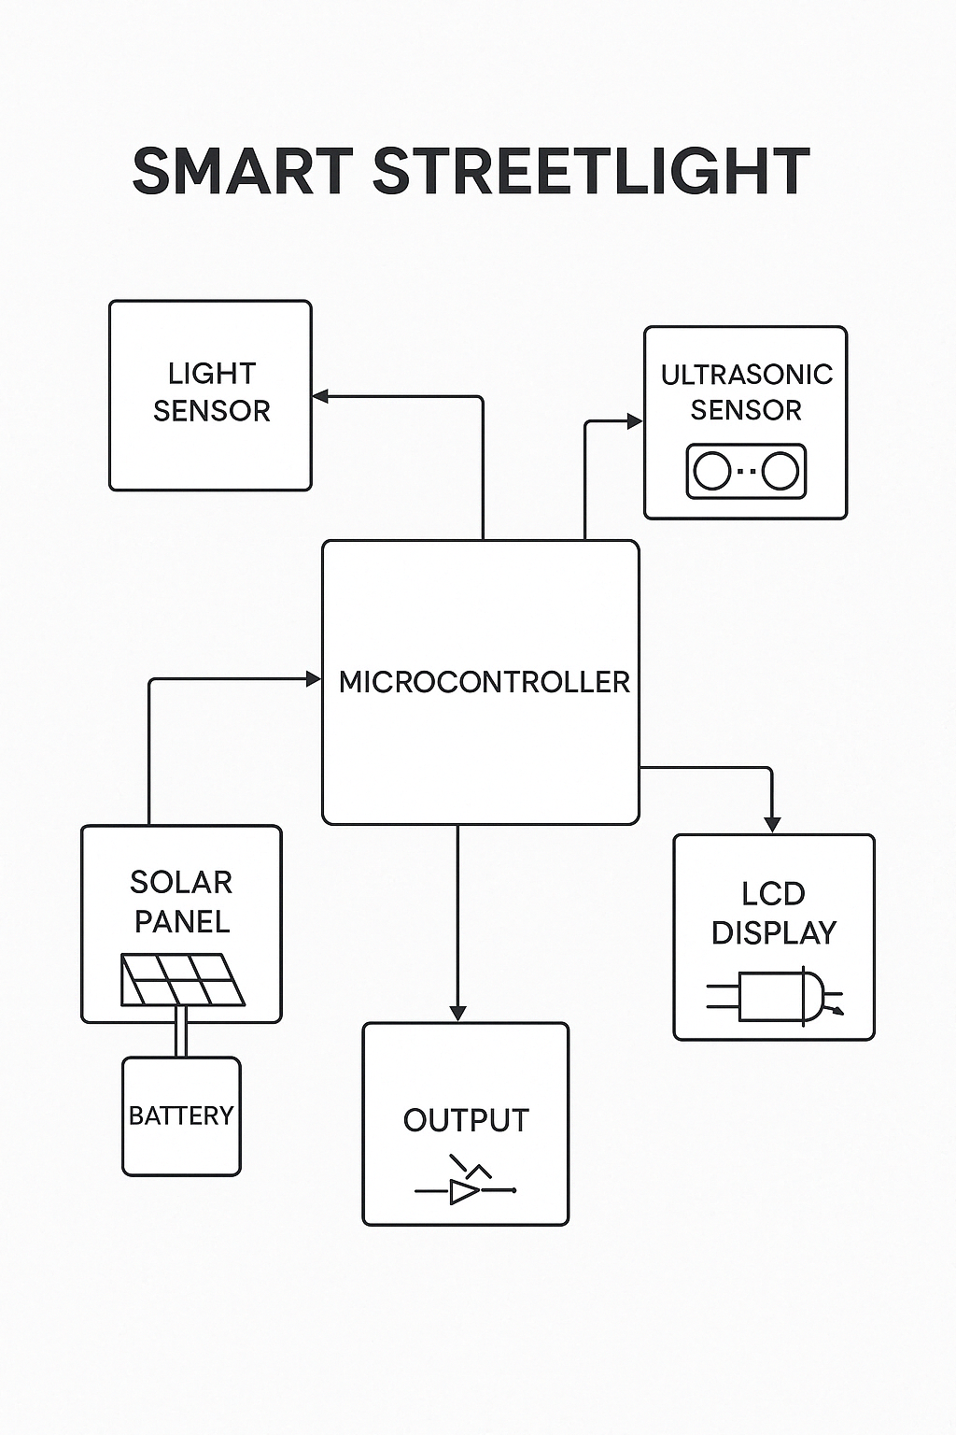

Circuit Diagram:
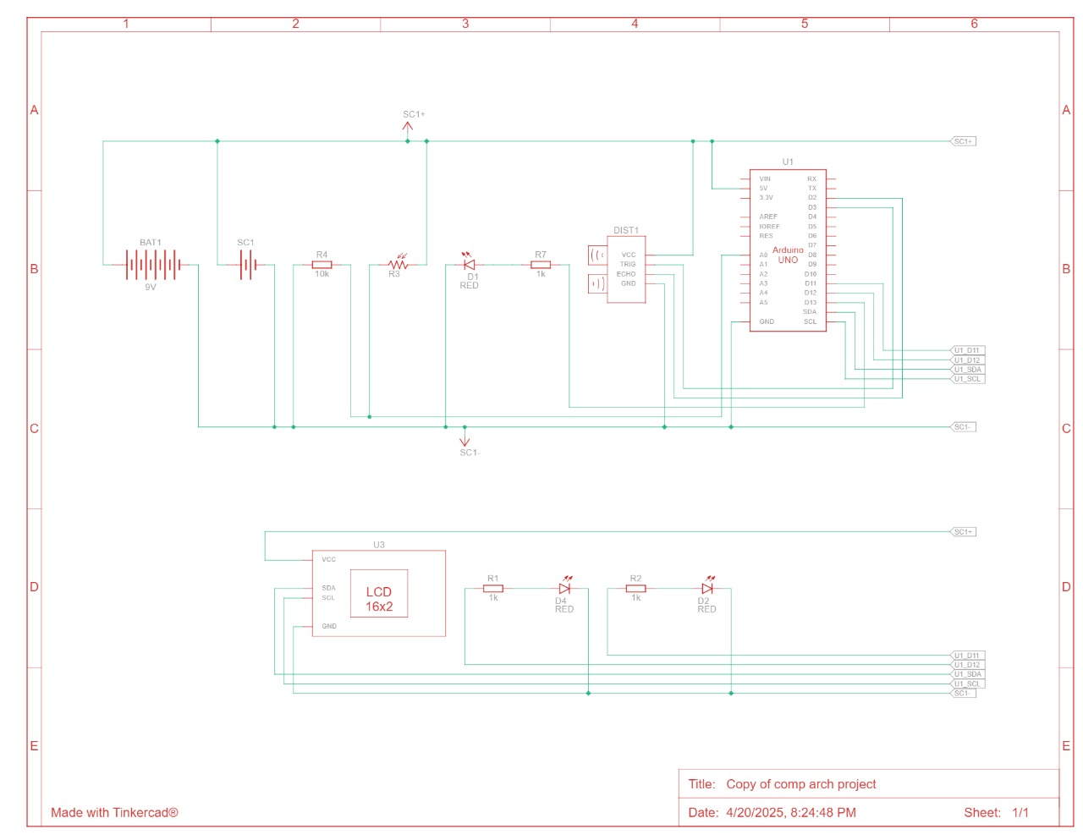

Flowchart:

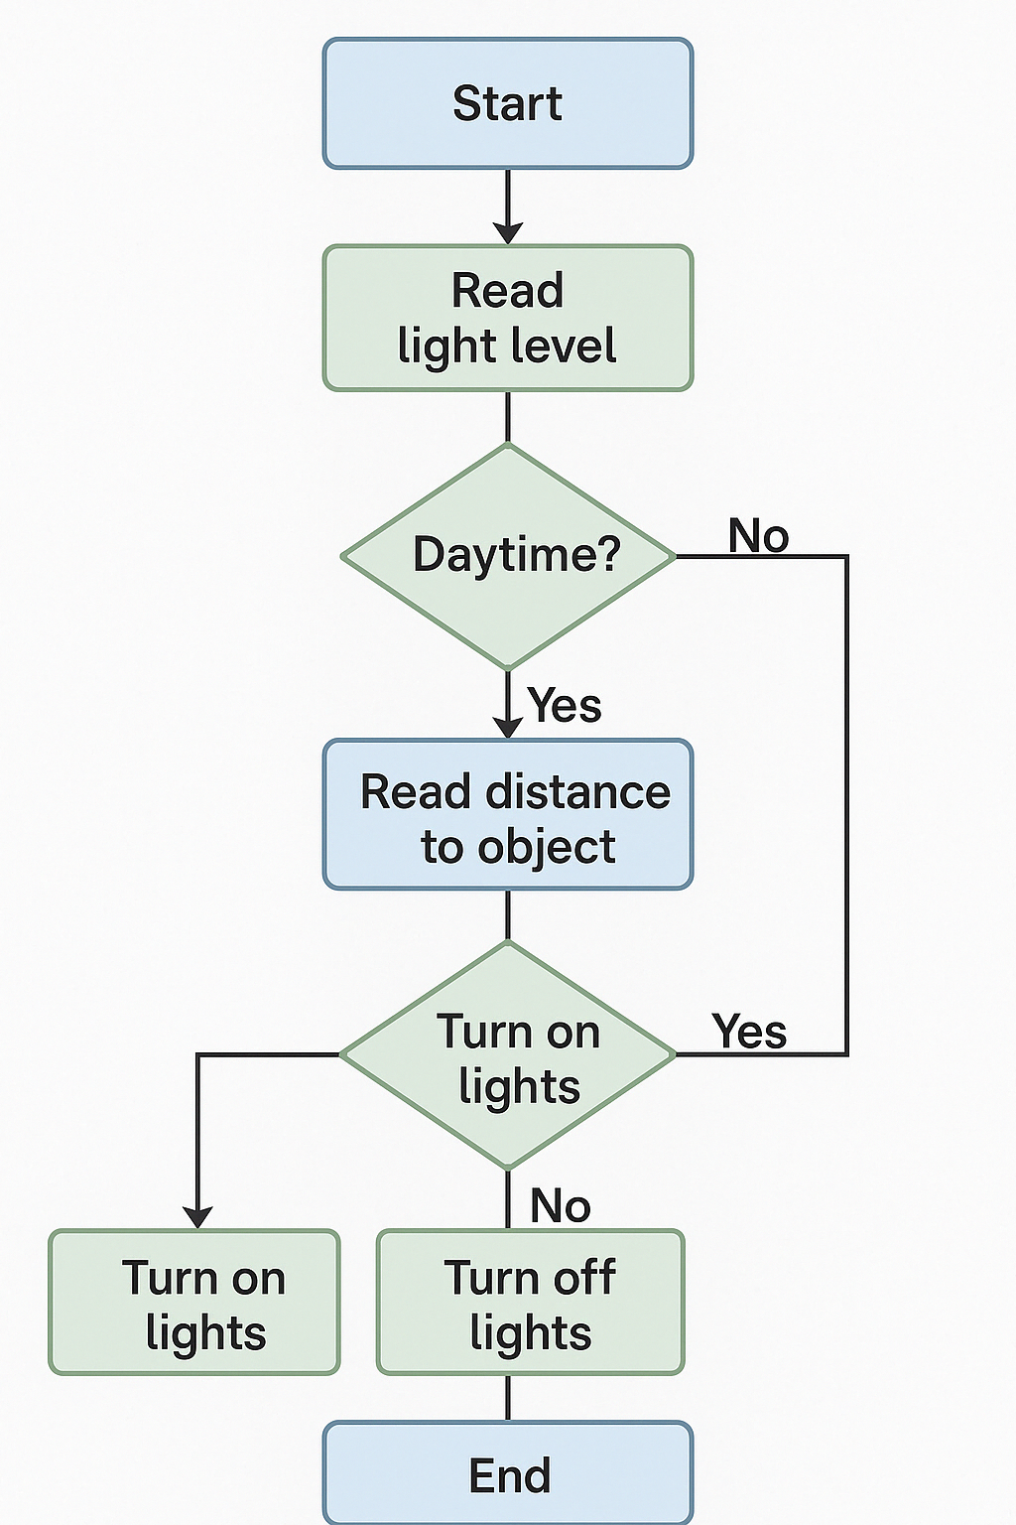

Implementation details with source code:
void setup()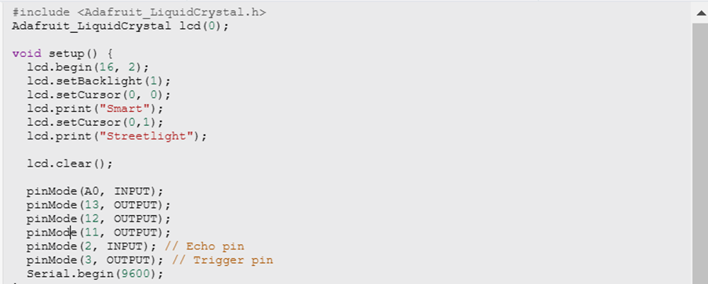
void loop()
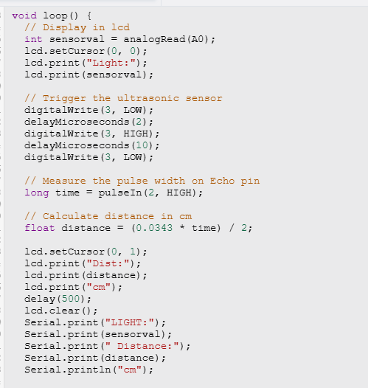
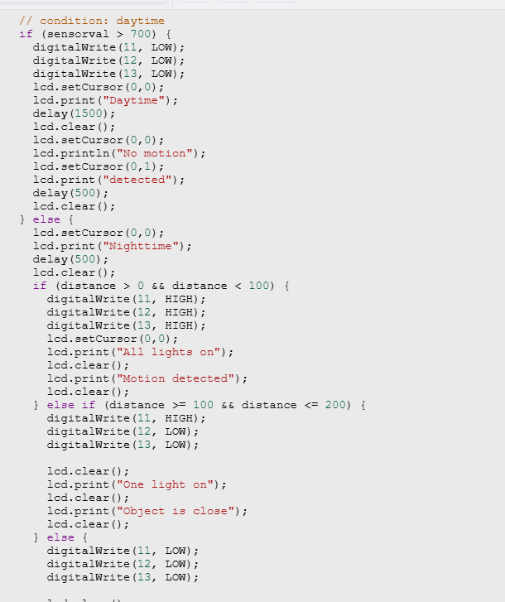


Before void setup():
We are calling the library to access the lcd’s functions
void setup():
In this part of the code:
1. The lcd screen is initialized with 16 rows and 2 columns.
2. The back light is turned on
3. The lcd will print smart streetlight for initialization that the code is running and it is based on smart street lighting system.
4. Then the lcd screen is cleared.
5. The next set of lines tells us the pins that are used and whether they are for input or output. For instance, the echo pin labeled 2 is input and pin 3 is labeled output.
6. The last line tells the serial monitor to display the output.
Void loop():
In this part of the code:
1. It will read the light intensity from the photoresistor.
2. It will display the light intensity and distance of the objects on the lcd screen and serial monitor.
3. If the intensity of light is greater than 700 then the LEDs will not turn on as it is daytime.
4. Otherwise, the lcd will glow depending on how close the object is.
5. For instance, if the object is getting near then one LED turns on and appropriate message gets displayed on the screen of LCD.
6. If the object is from distance 0 to 100 cm, then all the three LED’s will shine indication motion.
7. If there is no motion, then the LED’s will remain off even if it is nighttime.

Test cases and results:
Test case (1):

test case of everything working in tinkercad

test case (2):

test case of when object is far

Test case (3):

test case for the night when object is close

Test case (4):


proof of test (4) working for daytime when object is close lights and ultrasonic sensor are off.

test case (5):

proof that lights do not turn on even if the object is far in daytime

Future Work:
The plan is to enhance this street light system by adding more features and making it more sustainable. We aim to strengthen it in a way that helps manage traffic jams by adjusting the timing of the lights turning on / off. To better enhance the light to turn on correctly we will use an infrared sensor so lights do not turn on by wind-carrying objects or for some other reason. Additionally, we will explore the use of alternative clean energy sources to make the system more efficient and monitor energy consumption over time to check if the consumption is improved.

Conclusion:

The Smart Street Light System presents a significant advancement in urban infrastructure by addressing the need for energy-efficient and sustainable lighting solutions. By utilizing a combination of solar energy, motion detection, and ambient light sensing, this system optimally manages streetlight operation to enhance public safety while minimizing energy consumption. The integration of accessible components facilitates low-cost implementation, making it suitable for deployment in both developed and undeveloped areas.

References:
tinkercad - https://www.tinkercad.com/
Canadian university of dubai weekly labs 1 to 11 [unpublished]

